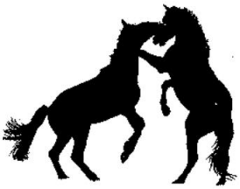
Announcing the Creation of the Central Connecticut Mustang and Burro Association

Finally, the mustang and burro owners of Connecticut have their own association!

With our first show season coming up in 2008 we are looking to gain members who wish to showcase their mustang or burro!

Join now and help us celebrate the spirit of the wild! Visit the website below for more information:

www.ctmustangsandburros.com
www.ctmustangsandburros.com
www.ctmustangsandburros.com
www.ctmustangsandburros.com
www.ctmustangsandburros.com
www.ctmustangsandburros.com
www.ctmustangsandburros.com
www.ctmustangsandburros.com
www.ctmustangsandburros.com
www.ctmustangsandburros.com
www.ctmustangsandburros.com
www.ctmustangsandburros.com
www.ctmustangsandburros.com

